**Census Income data - Story**

A few questions that were explored using the demographic income set – Identify major determinants of earnings potential

|  |  |  |
| --- | --- | --- |
| High Earners | Population cells tagged as 50000+ | 6.4% |
| Low Earners | Population cells tagged as - 50000 | 93.6% |

**Q1. Do High earners tend to be older ?**

Indicatively high earners do tend to be older around ~ 45 years vs ~30 for low earners – This is driven by high volume of young professionals in the low earners.

50% low earners are under 30 while only 5% high earners are under 30



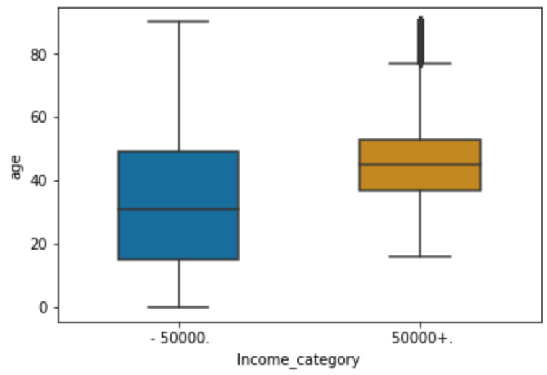

**Q2. Do higher earners tend to be employed by firms with more employees ?**

Boxplot below indicates that larger firms tend to pay their employees higher

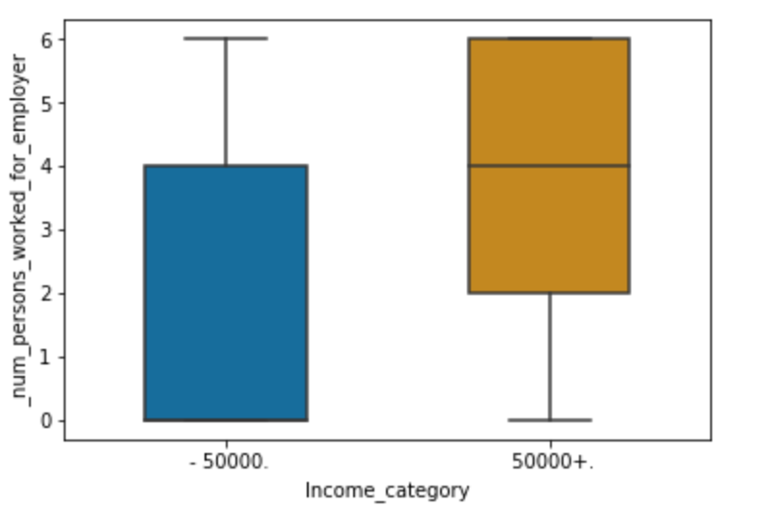

**Q3. Does marital status have any implications for earning**

‘Married-civilian spouse present’ category has a 11.9% high earner rate. There seems to be a casual relation between a stable marriage and earnings potential

Q Are men paid more than women

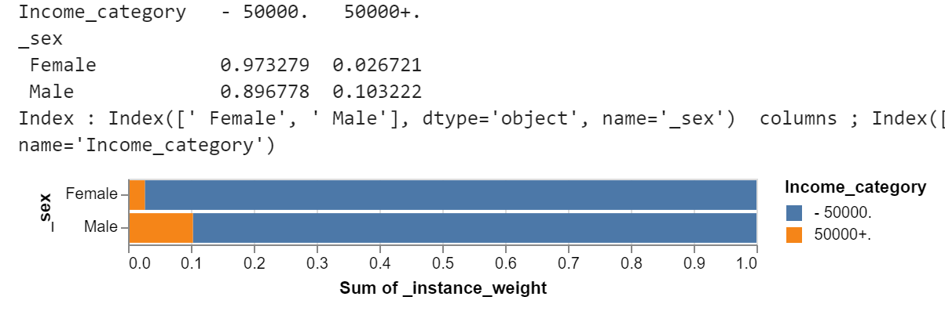

**Q4. How much does education impact earnings potential ?**

Earnings potential increases as educational qualification increases, which agrees with prevailing understanding and justifies high cost of higher education to some extent

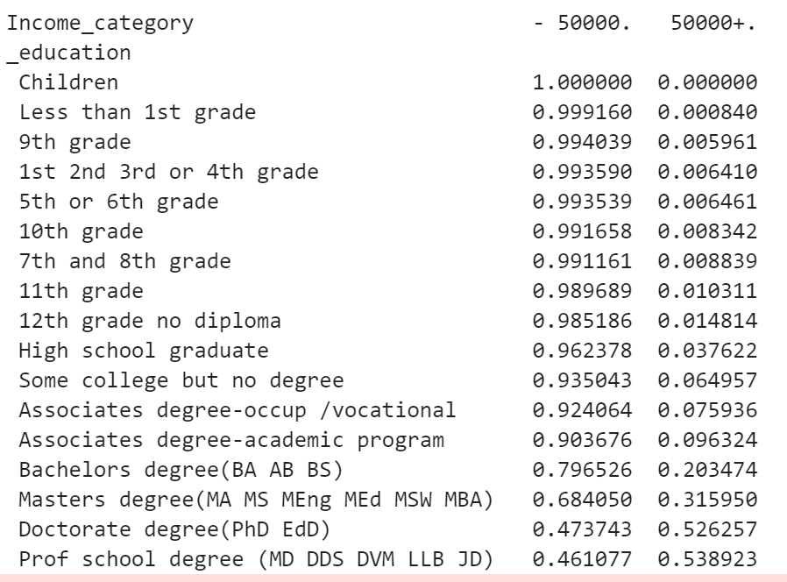

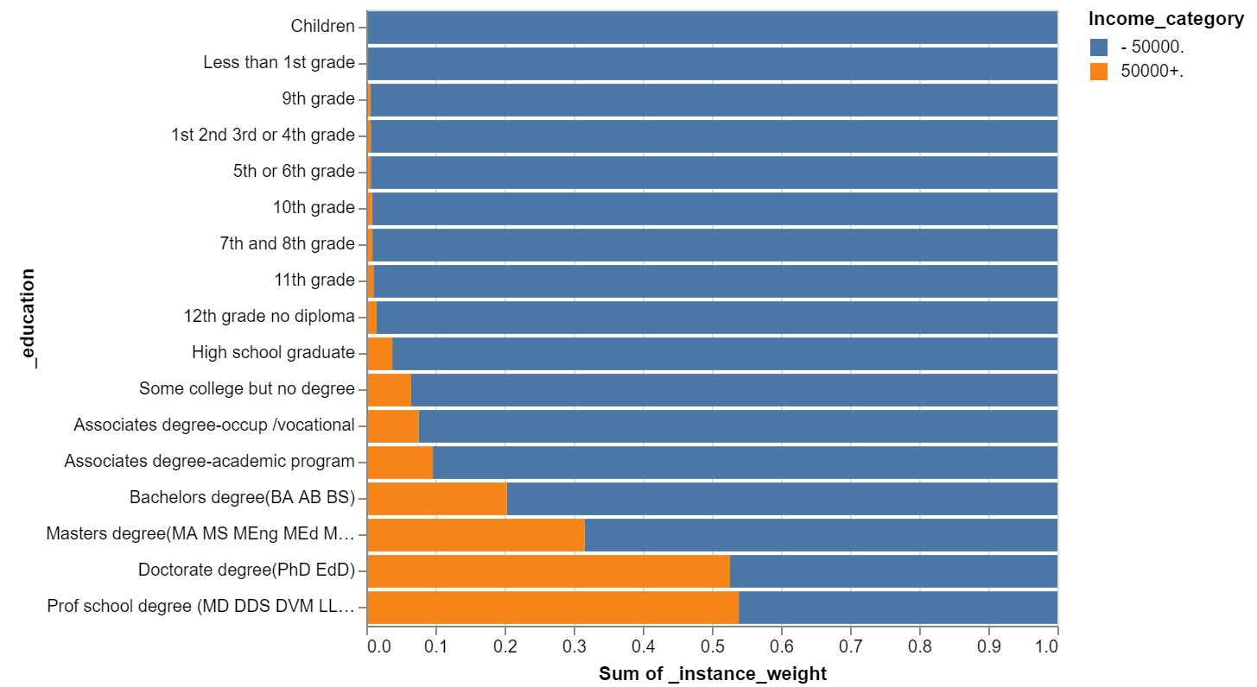

**Q5. Do labor union members have higher earning potential in general ??**

Maybe a slight advantage. Need to analyze further.

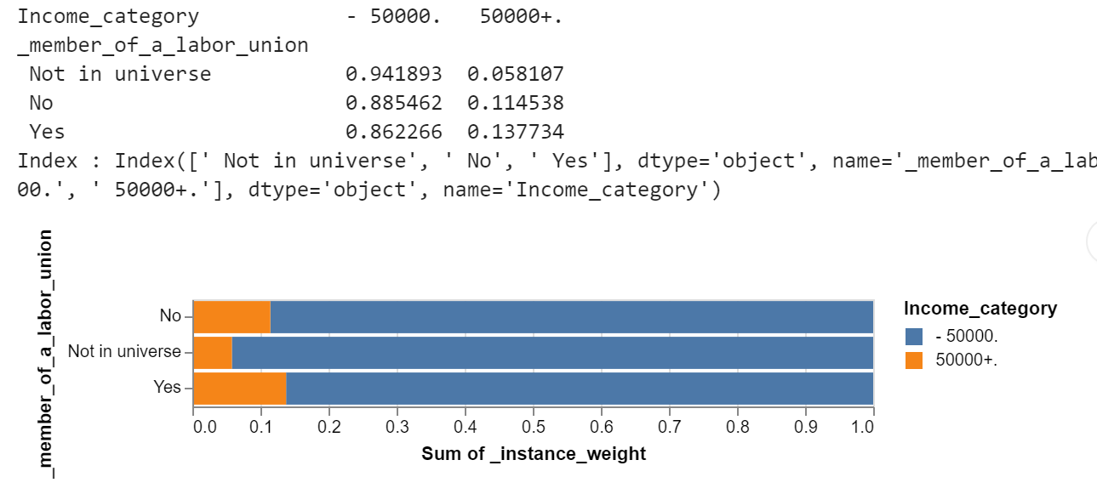

**Q6. Are there any visible trends based on father / mother country of origin - Do immigrants tend to earn higher or lower ?**

Population with immigrant parents tend to have higher earnings potential based on heatmap below – area marked within box

* Some of the dark red cells tend to be driven by lower population in the cell (low denominator)
* The data agrees with common beliefs around mating patterns – ex. First generation Asian-Indians dont seem to have non Indian partners, which makes sense in 1994-95 (Period of data), given conservative views. In a similar vein English/French/German nationals seem to have partners amongst each other.
* There seems to be a relatively higher concentration of high earners within populations where both parents are non US, as depicted by the darker reds within the square

A heat map of Father / Mother birth country – color coded by % high earners (i.e. 5000+ population) in cell

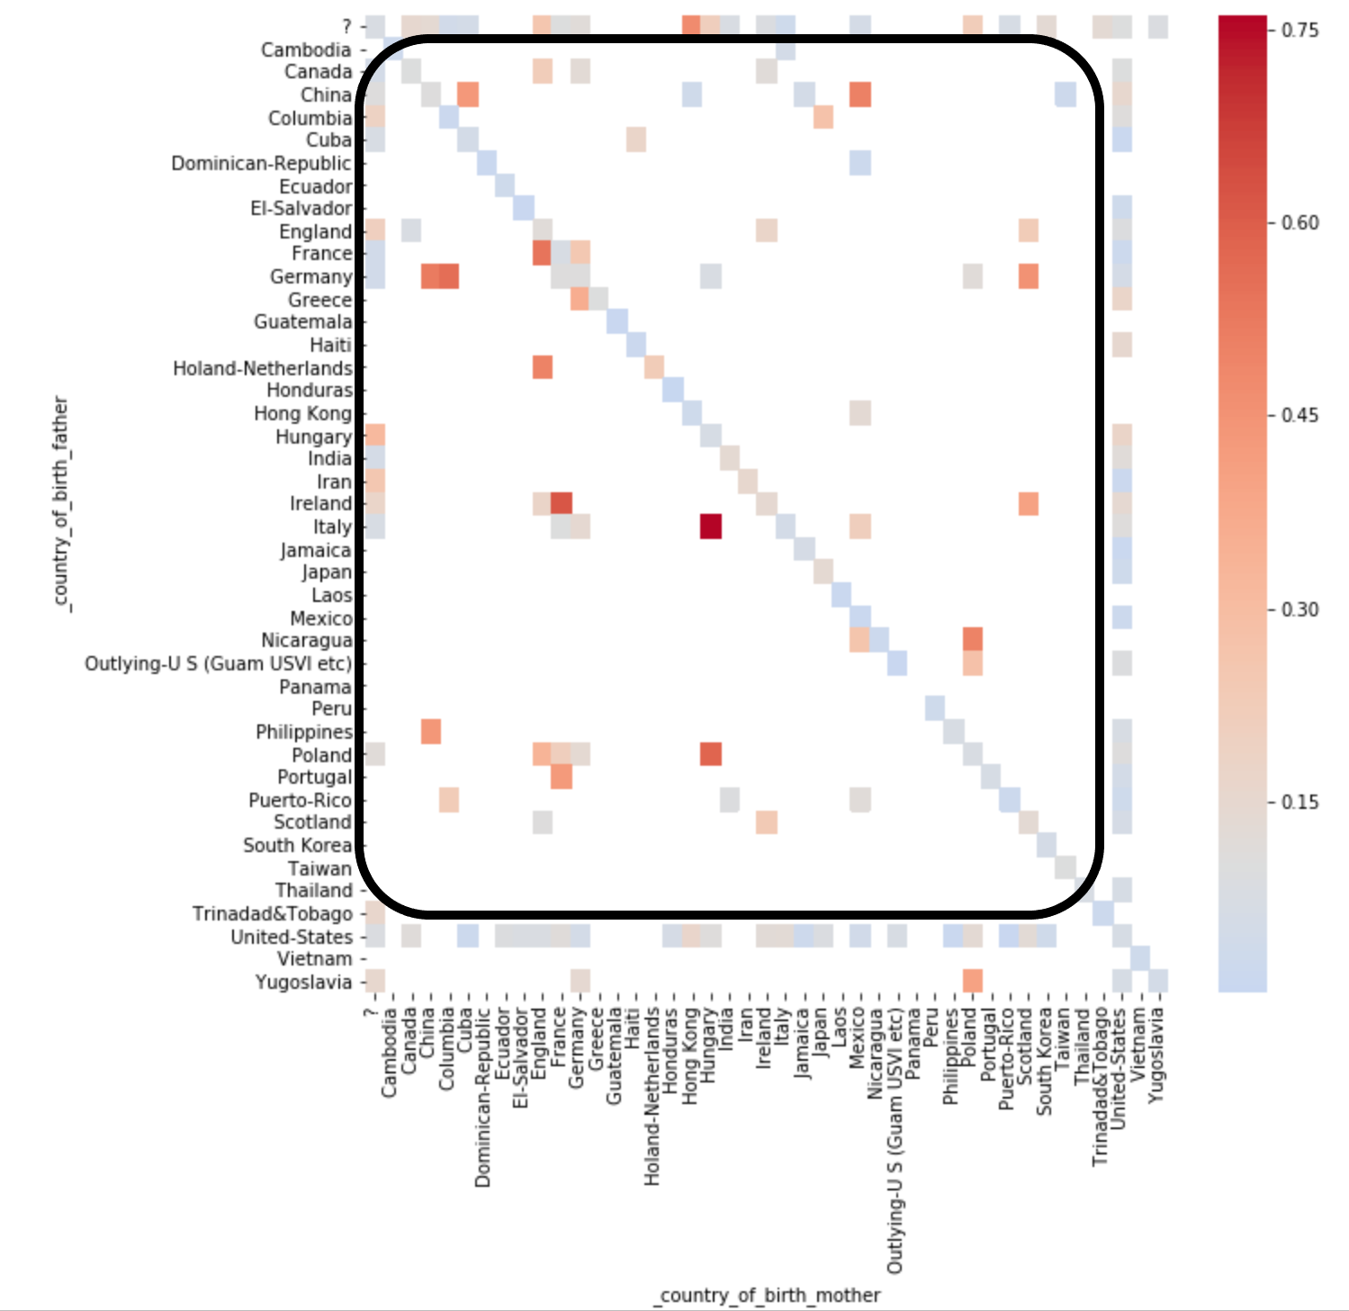

**Conclusion**

Key drivers of high income seem to be Age, Education, Gender and Firm size. Parent’s original birth country seems to be an important variable as well.

Labor union participation also seems to be favorable for high earning but we need to further investigate.